**(Make sure to push all your code on your github).**

**Task # 1:-**

Use whatever we learned so far to create this table.

Hints:-

Use Gradient colors in background (BG should not be white).

Make a container and add table to it.

Set width of container and center it using margin: auto.

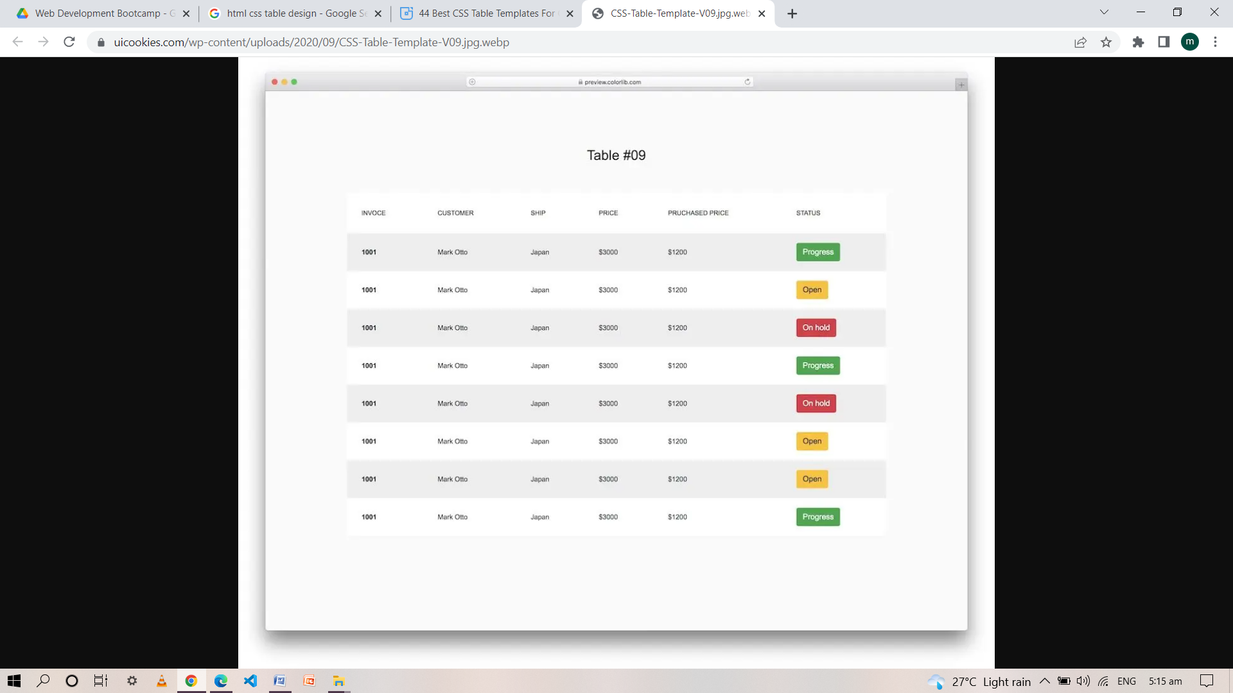

**Task # 2:-**

Create a page for a recipe website similar to the image below.

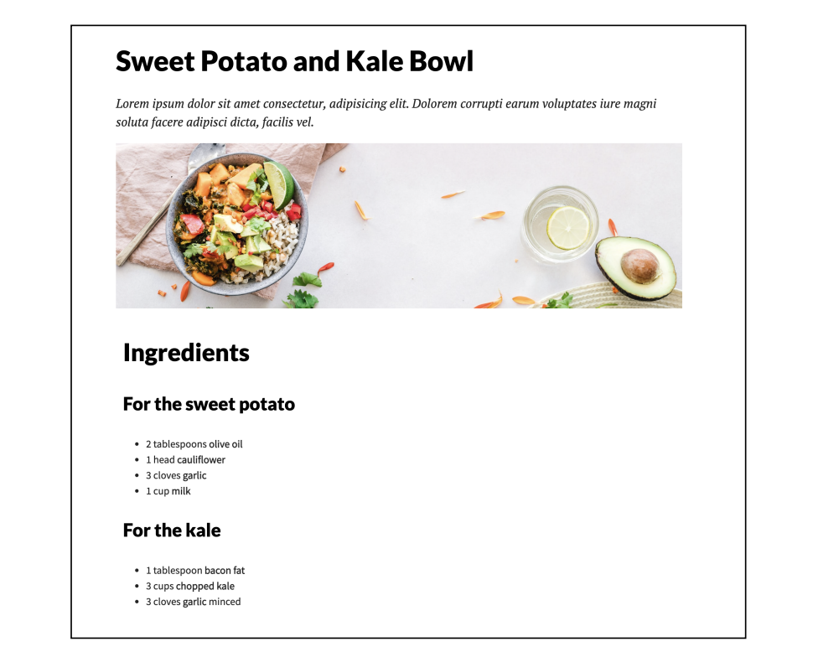

Use Google fonts to add beautiful fonts to your website.

Create a github repository and push your code to github.

**Task # 3:-**

Create simple Cards as shown in the image below.

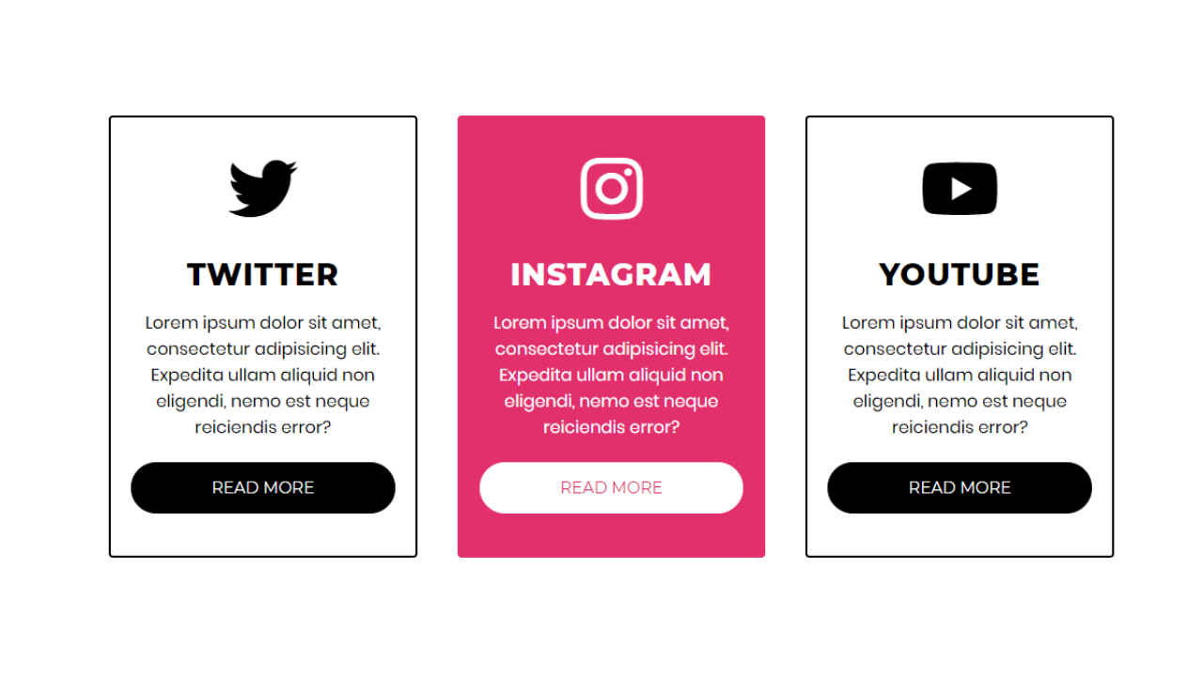

Hints:-

Create three divs and display them as inline to represent in a single row

Add some hover effects like middle one. (Background color and text color should be change whenever you hover over whole card)

**Good Luck**